**Zara Sales Optimization Leveraging Tableau for Product Performance and Market Trend Analysis**

**Problem Statement:**

ABC Company, a retail conglomerate, aims to optimize its sales strategy and enhance profitability across its stores. To achieve this goal, ABC seeks to leverage data-driven insights from its Zara sales dataset, which contains comprehensive information on product sales, including product attributes, sales volume, promotions, and store locations. The company aims to address several key challenges, including identifying top-performing product categories, understanding the impact of promotions on sales volume, analysing seasonal trends, and optimizing inventory management strategies. By harnessing the power of analytics through Tableau, ABC intends to extract actionable insights that will inform strategic decision-making processes, drive targeted marketing efforts, and improve overall sales performance and customer satisfaction.



**Prerequisites:**

* Basic understanding of Data Analytics

[What Is Data Analytics? - An Introduction (Full Guide)](https://youtu.be/yZvFH7B6gKI?si=jD37tQzKJH1vl56A)

* Awareness of the lifecycle of a Data Analytics Project

[A Beginners Guide To The Data Analysis Process](https://youtu.be/lgCNTuLBMK4?si=a_J79oNSQIGNuNlH)

* Understand Tableau Interface- [Link](https://www.youtube.com/watch?v=oIw8xJ1Fy3w)
* Download Tableau Desktop-[Link](https://www.tableau.com/products/desktop/download)

**Objective:**

An objective is a specific, measurable, and time-bound goal or target that an individual or organization aims to achieve. Objectives are typically set to guide actions and decision-making towards desired outcomes. They are often a part of broader goals and help to clarify what needs to be accomplished within a certain timeframe. Objectives should be realistic, achievable, and relevant to the overall mission or purpose, providing a clear direction for efforts and resources.

**Task:**

* Visualize sales volume, total price, and total count of Zara products to provide a holistic view of sales performance, enabling stakeholders to identify top-selling products and categories.
* Analyse product category by gender to understand purchasing behaviour across different demographic segments, facilitating targeted marketing efforts and personalized product recommendations.
* Explore product positioning within stores and analyse sales trends to optimize product placement strategies, enhancing customer engagement and maximizing sales potential.

**Dataset**: [Link](https://www.kaggle.com/datasets/xontoloyo/data-penjualan-zara)

**Solution Development Procedure:**

* In Tableau, the "Connect" option refers to the initial step in the data visualization process where users connect to various data sources to import data into Tableau for analysis and visualization.

* When you select the "Connect" option in Tableau, you are presented with a variety of data connection options.



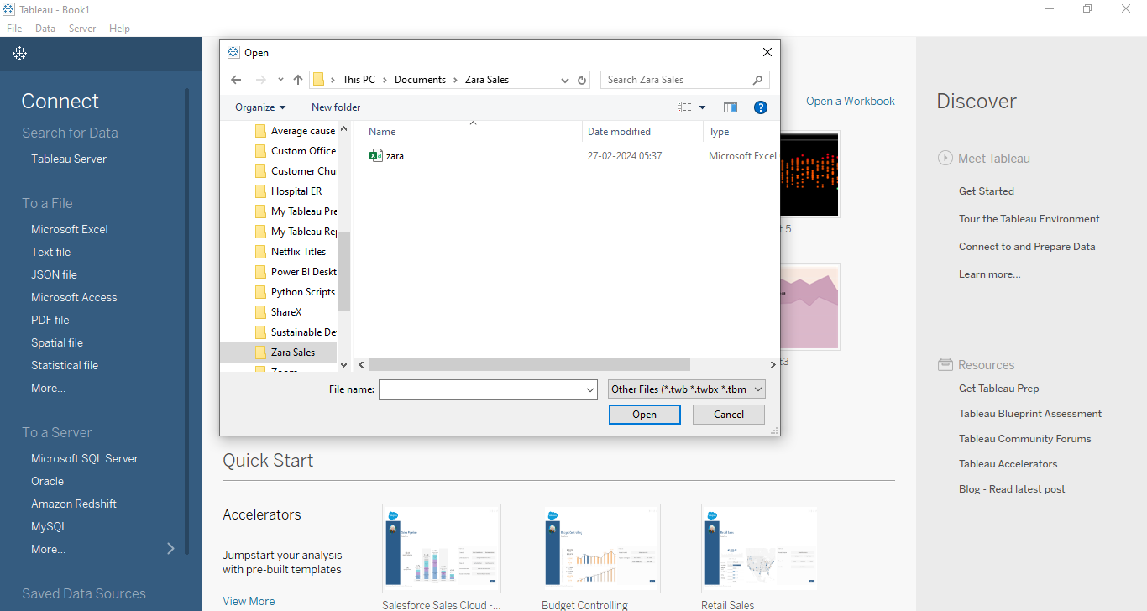

* Once we load the data into the Tableau.

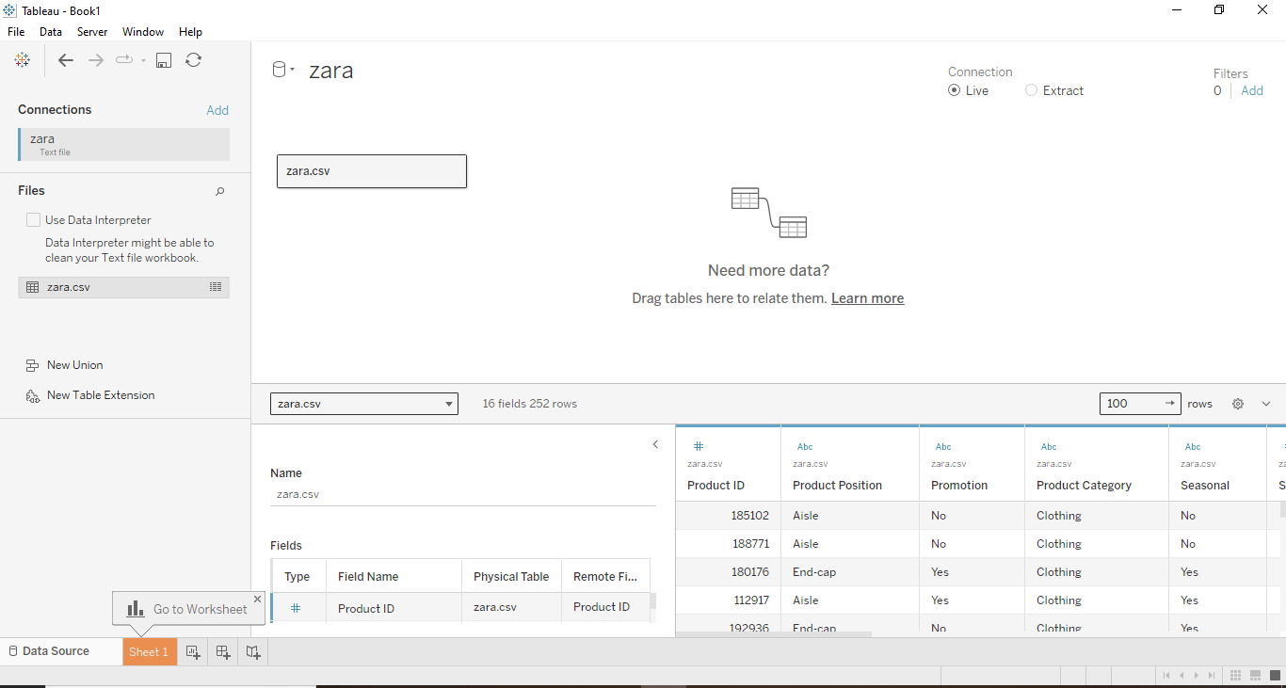

* Now , we proceed to create dashboard for Zara Sales Insights.
* To create the dashboard, which will satisfy the task above, we consider the followingcolumns:
  + Product Category By Gender, Positioning and Sales
  + Sales Trends and Product Positioning by Category
  + Total Prices in Zara
  + Total Count of Products in Zara
  + Sales Volume in Zara
* We have created the dashboard which is presented below.

**Dashboard:**

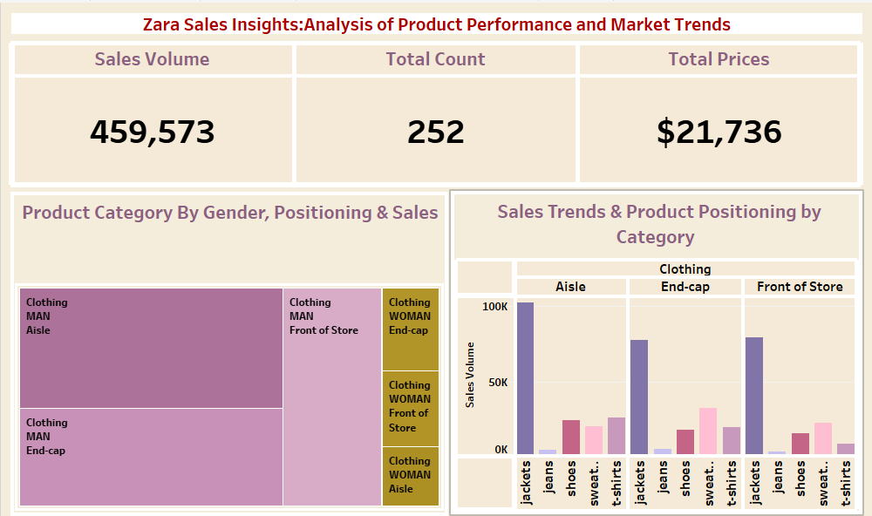

**Explanation Video:** Link

Note: The explanation video for the dashboard is in the link above.

**Insights:**

Insights refer to valuable and meaningful understandings or perceptions gained from analysing data, information, or experiences. They provide deeper understanding, clarity, or revelation regarding a particular subject or situation.

* Despite a relatively low total count of 252 items sold, the total price of $21,736 indicates a high average price per item, suggesting that Zara is effectively selling higher-priced products or successfully implementing pricing strategies to maximize revenue per transaction.
* With a sales volume of 459,573 units, the discrepancy between total count and sales volume highlights the importance of analysing the relationship between sales volume and total price. This insight can help identify product categories or individual items with high demand but relatively low prices, indicating potential opportunities to adjust pricing strategies or promote higher-value products to increase overall revenue.

**Conclusions :**

Conclusions are logical deductions or decisions drawn from observations, evidence, or analysis. Conclusions are often based on the findings or results of a study, experiment, or evaluation, and they aim to summarize key insights or outcomes. Effective conclusions should be supported by evidence, logical reasoning, and critical thinking, leading to well-informed decisions or actions.

* Zara has potential for increasing revenue through price optimization, as indicated by the high total price despite a relatively low total count of items sold.
* Analysing sales volume and total price across different product categories and genders can help identify opportunities for adjusting pricing strategies to better align with customer preferences.
* Strategic product placement within stores is crucial for maximizing sales opportunities, and insights derived from analysing product positioning and sales trends by category can inform decisions about store layout and promotional strategies.